RAG-Driven Intune App Packaging Automation – Project Requirements Outline

0. Project Goal and Scope
This document defines all resources, dependencies, configuration steps, and coding requirements needed to build an internal RAG-driven automation for Intune Win32 app packaging. The outline is designed to be used as a project tracking artifact.

1. Windows Build Host
Purpose: Executes ingestion, embedding, script generation, and IntuneWinAppUtil packaging.
Resources Required:
- Windows Server 2019/2022
- PowerShell 5.1 (required), PowerShell 7 (optional)
- IntuneWinAppUtil.exe
- .NET Framework 4.7.2
Setup Steps:
1. Provision VM and join domain
2. Install tooling
3. Validate network access
Context Flags: [INFRA], [CONFIG], [OPS]

2. Service Account and Security
Purpose: Identity used by automation.
Resources Required:
- Domain service account
- File share permissions
- PostgreSQL credentials
Setup Steps:
1. Create service account
2. Grant read access to script library
3. Grant DB permissions
4. Secure secrets storage
Context Flags: [SEC], [CONFIG]

3. PostgreSQL + pgvector
Purpose: Vector database for RAG retrieval.
Resources Required:
- PostgreSQL 14+
- pgvector extension
Setup Steps:
1. Provision database
2. Enable pgvector
3. Create rag_chunks table
4. Configure firewall and TLS
Context Flags: [INFRA], [CONFIG], [SEC]

4. Embedding Provider
Purpose: Generate embeddings for RAG.
Resources Required:
- Azure OpenAI or equivalent
- Embedding deployment
Setup Steps:
1. Provision embedding model
2. Capture embedding dimension
3. Secure API keys
Context Flags: [CONFIG], [SEC]

5. Script Library (Corpus)
Purpose: Source-of-truth for retrieval.
Resources Required:
- File share library
Setup Steps:
1. Define include/exclude paths
2. Add standards documentation
Context Flags: [CONFIG], [OPS]

6. Spec Schema and Validation
Purpose: Deterministic generation and enforcement.
Resources Required:
- JSON Schema
- Preflight validator script
Setup Steps:
1. Version schema
2. Deploy validator
3. Enforce naming and policy rules
Context Flags: [CODE], [TEST]

7. RAG Ingestion Pipeline
Purpose: Chunk and index corpus.
Resources Required:
- Ingestion PowerShell script
Setup Steps:
1. Run initial ingestion
2. Validate chunks.jsonl output
3. Schedule incremental runs
Context Flags: [CODE], [OPS]

8. Embedding Write Pipeline
Purpose: Write embeddings to pgvector.
Resources Required:
- Embedding write PowerShell script
- Npgsql library
Setup Steps:
1. Install Npgsql
2. Run backfill load
3. Enable incremental updates
Context Flags: [CODE], [TEST]

9. Retrieval Module
Purpose: Fetch relevant context for generation.
Resources Required:
- Retrieval script/module
Setup Steps:
1. Embed query
2. Run pgvector similarity search
3. Return top-K chunks
Context Flags: [CODE]

10. Generation Orchestrator
Purpose: Prompt → Spec → Scripts.
Resources Required:
- LLM provider
- Prompt templates
Setup Steps:
1. Implement spec generation
2. Validate spec
3. Generate scripts
Context Flags: [CODE], [TEST]

11. Packaging (.intunewin)
Purpose: Create deployable Intune artifacts.
Resources Required:
- IntuneWinAppUtil.exe
Setup Steps:
1. Stage Source/Output folders
2. Run IntuneWinAppUtil
3. Validate artifact
Context Flags: [CONFIG], [TEST]

12. Intune Testing
Purpose: Validate deployments.
Resources Required:
- Intune dev tenant or pilot group
Setup Steps:
1. Assign app
2. Monitor install
3. Review IME logs
Context Flags: [TEST], [OPS]

13. Operations and Runbooks
Purpose: Support and scale solution.
Resources Required:
- Documentation
Setup Steps:
1. Write troubleshooting guide
2. Define promotion workflow
Context Flags: [DOC], [OPS]

Dependency Diagram
This diagram summarizes the key prerequisites and execution flow across resources. Use it to identify blockers and plan sequencing.
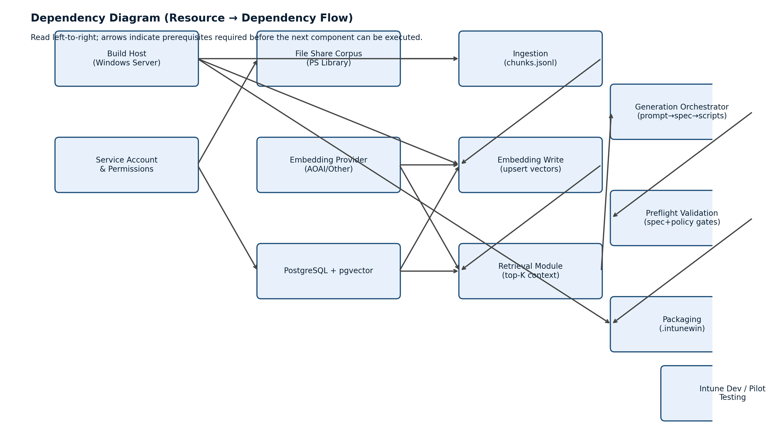

Dependency Diagram (Full)
Updated diagram with expanded canvas to prevent cropping. Use this version for presentations and project tracking.
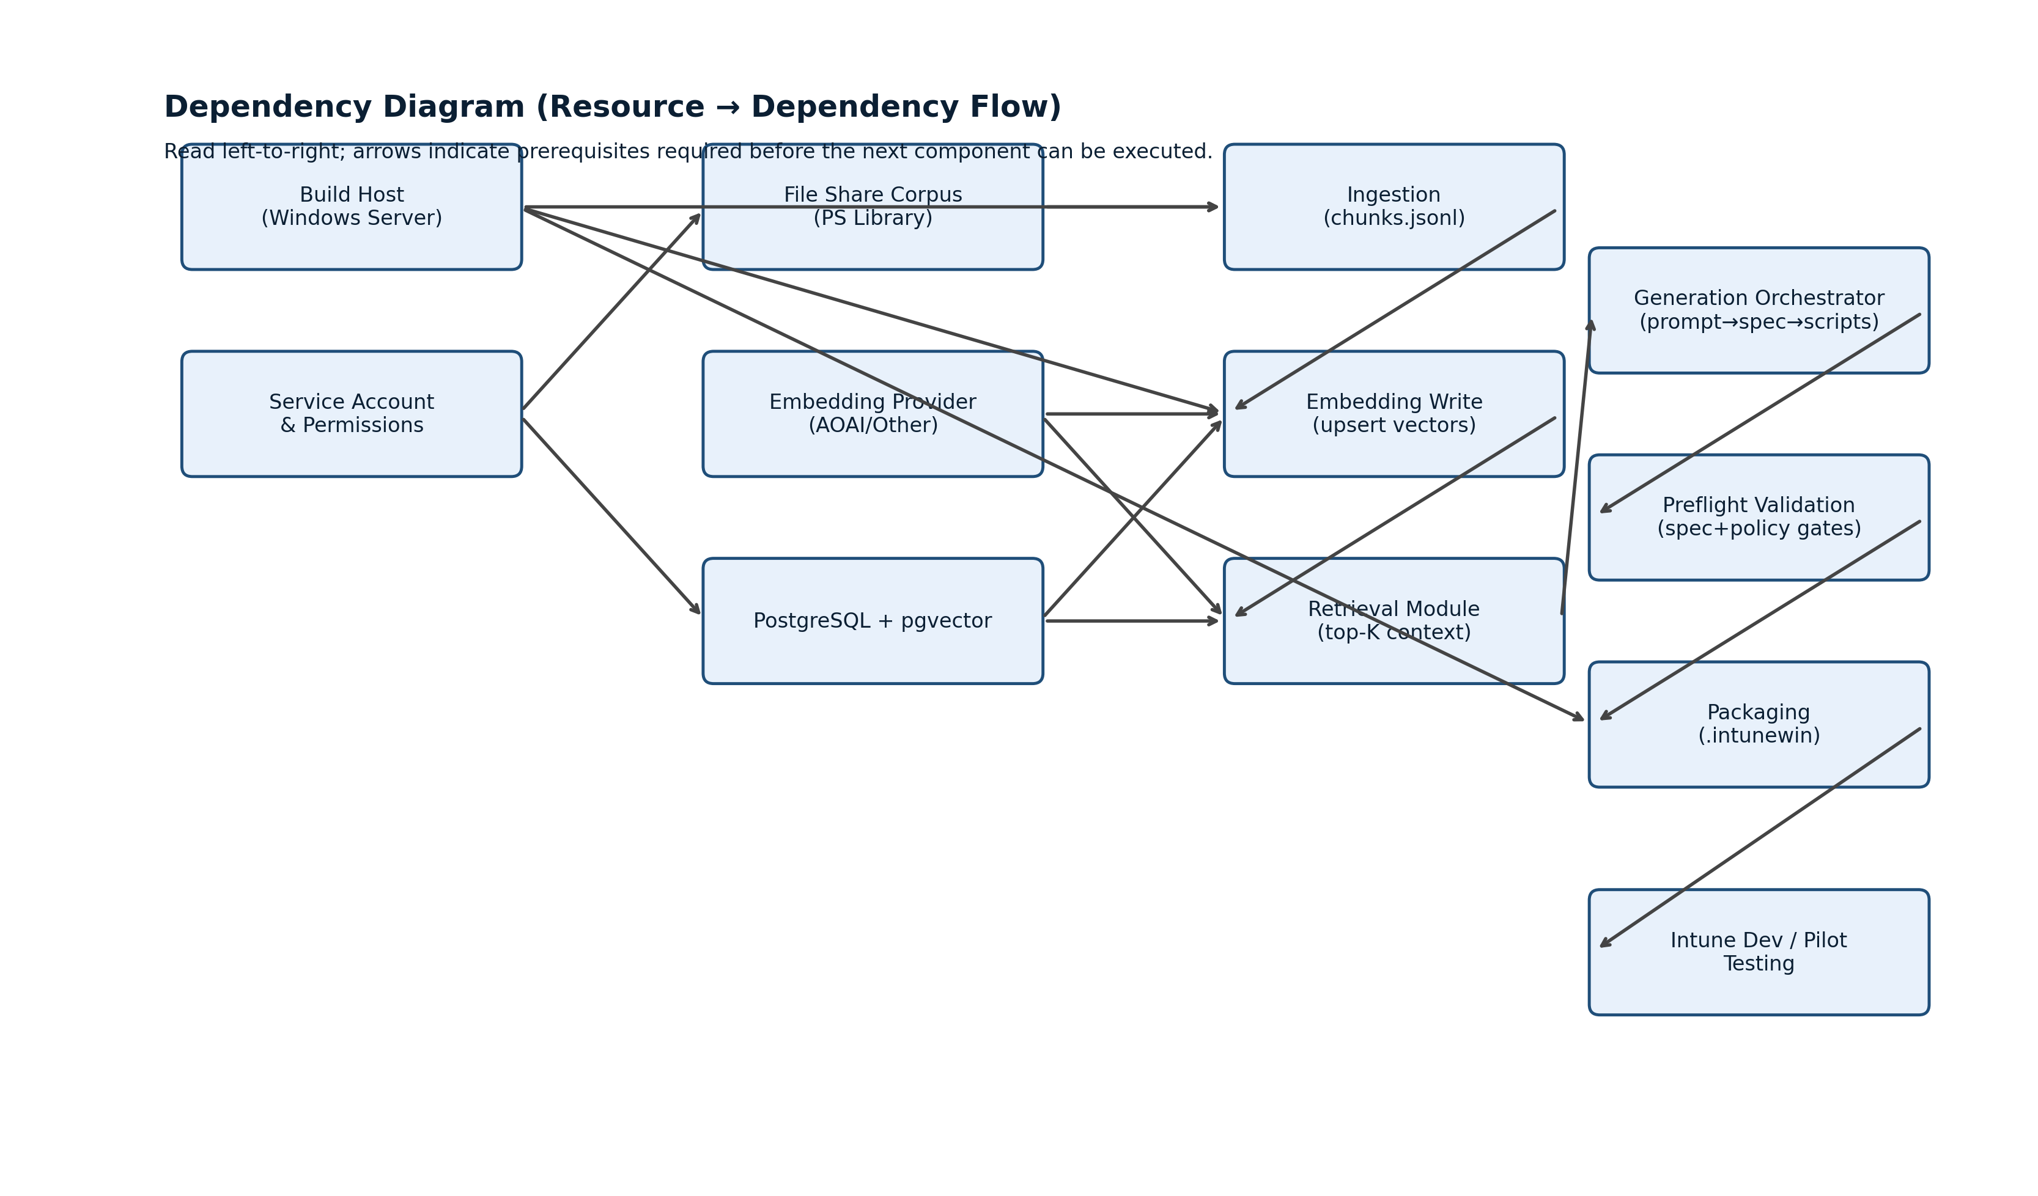

Dependency Diagrams (Split View)
The original dependency diagram has been split into two parts for readability: (1) Data Plane / Indexing and (2) App Plane / Generation & Delivery.

Part 1: Data Plane / Indexing
Focus: File share corpus ingestion, embedding generation, and writing vectors into pgvector.
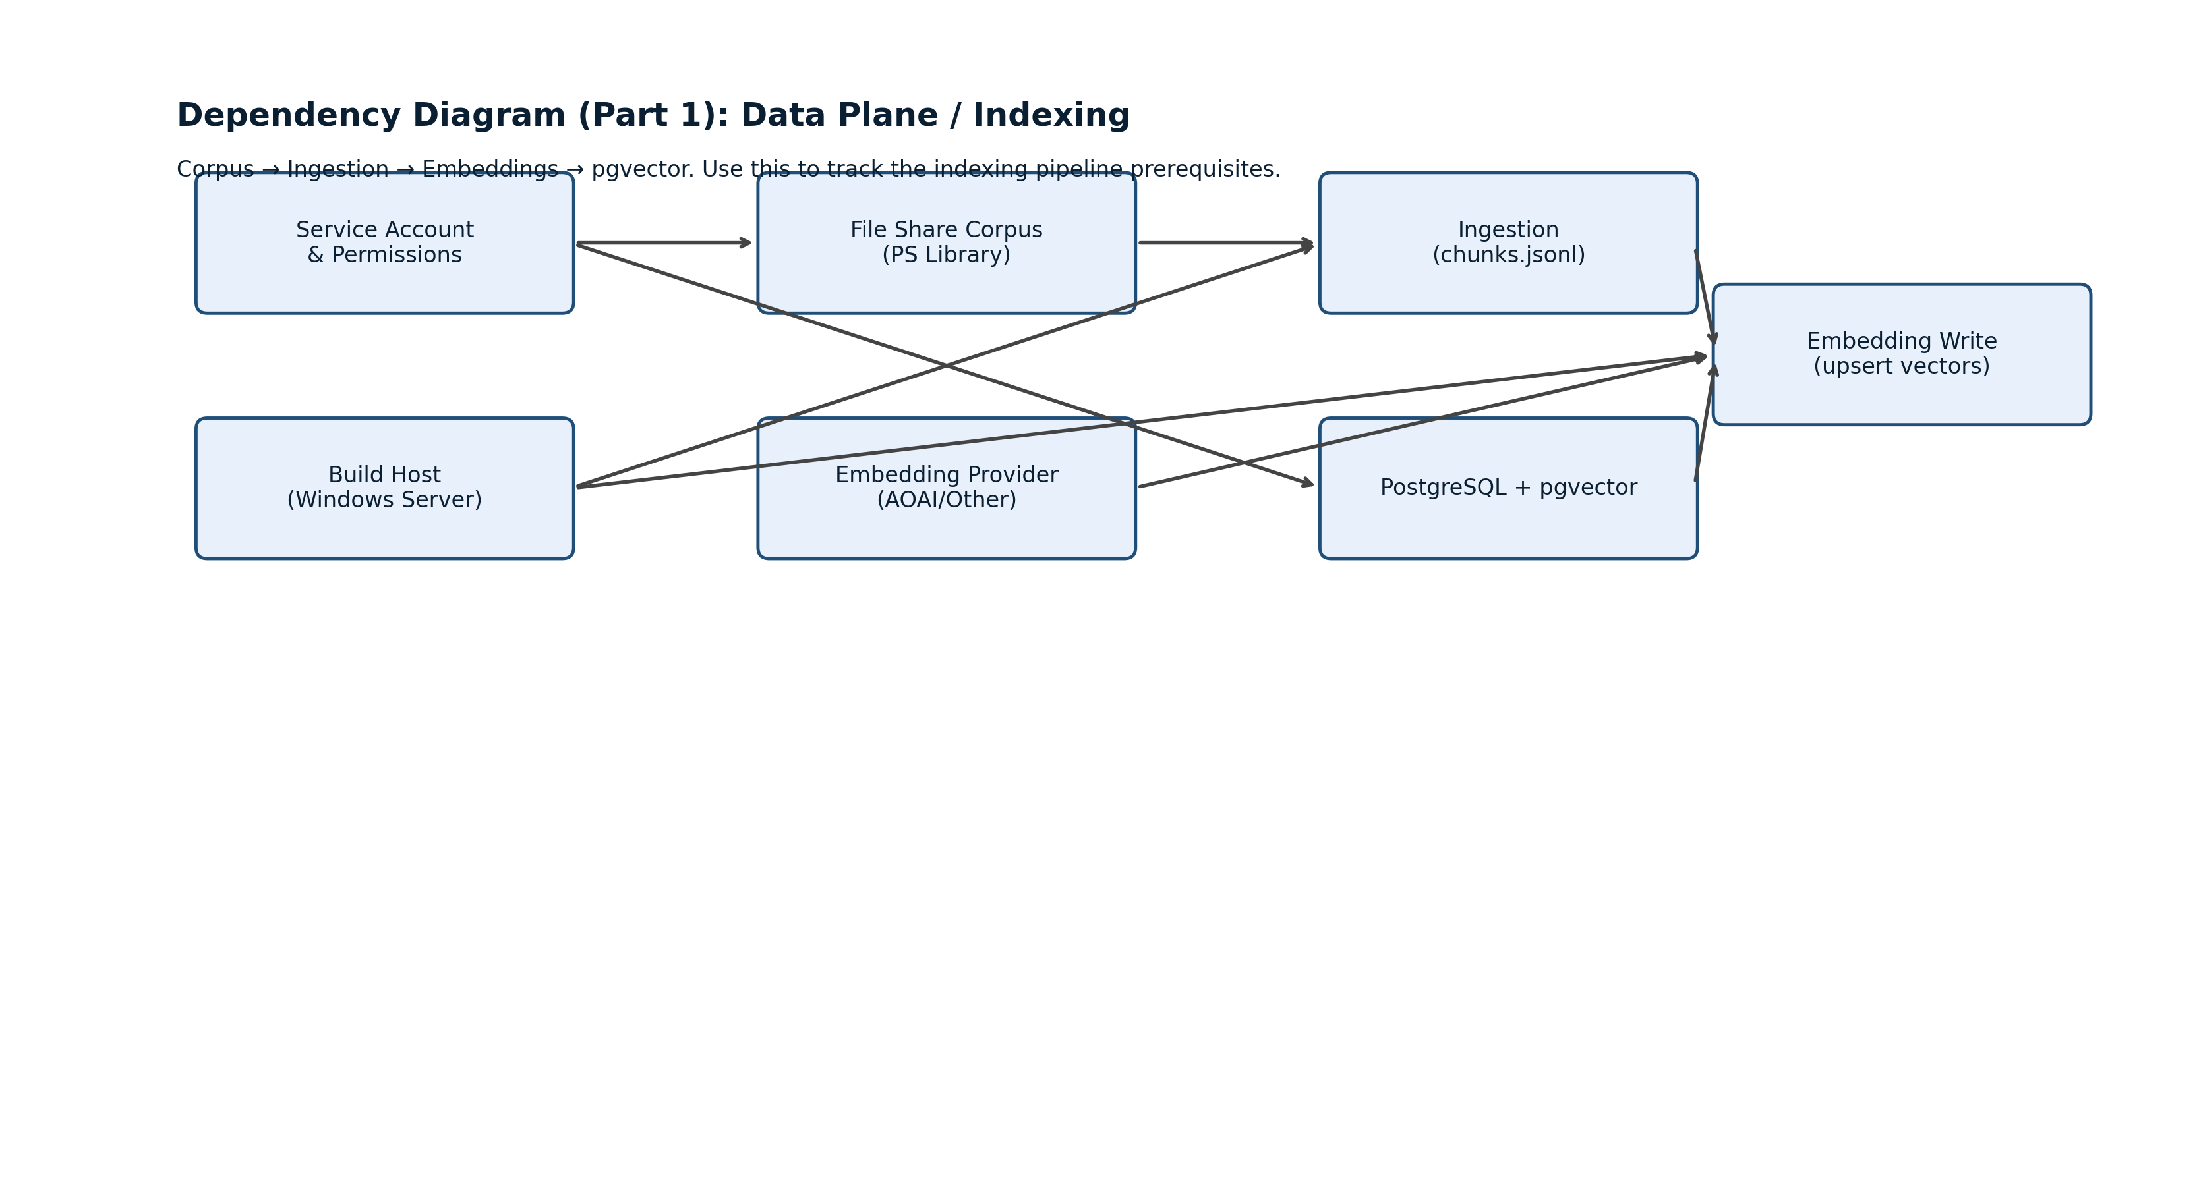

Part 2: App Plane / Generation, Packaging, Testing
Focus: Retrieval for RAG, spec/script generation, validation gates, packaging, and Intune dev/pilot testing.
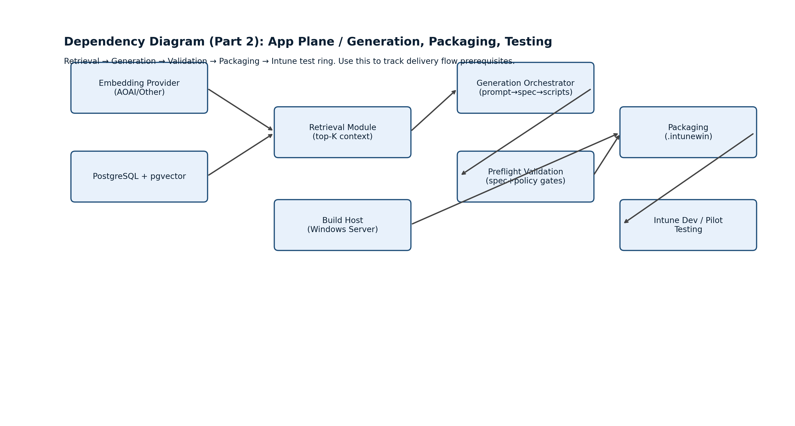

Dependency Diagrams (Cleaned)
These diagrams replace the earlier versions and ensure all arrows originate from visible resources. They are split into (1) Data Plane / Indexing and (2) App Plane / Generation & Delivery.

Part 1: Data Plane / Indexing (Clean)
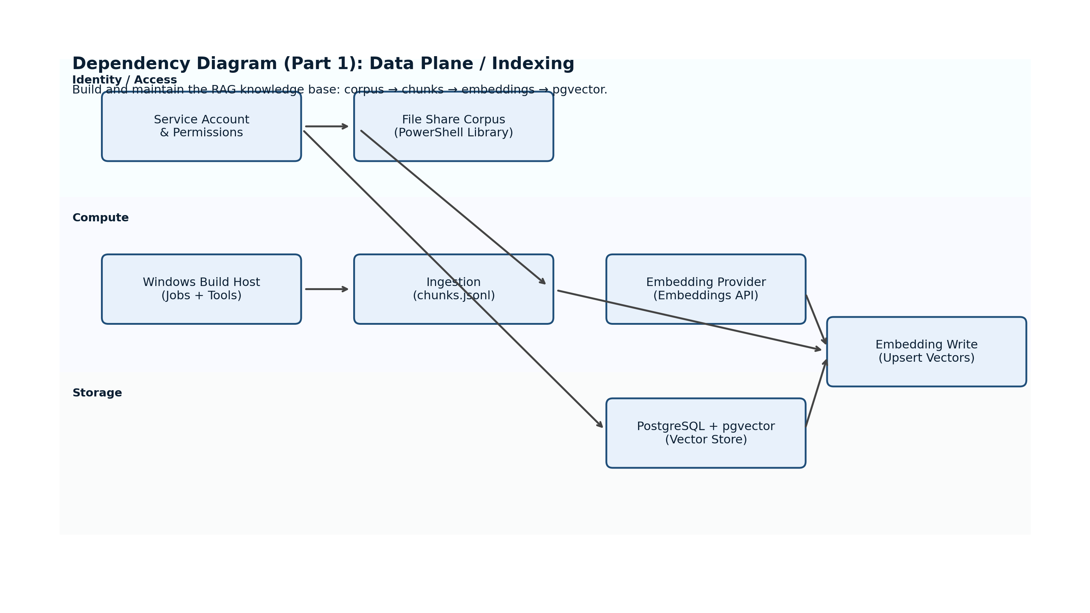

Part 2: App Plane / Generation & Delivery (Clean)
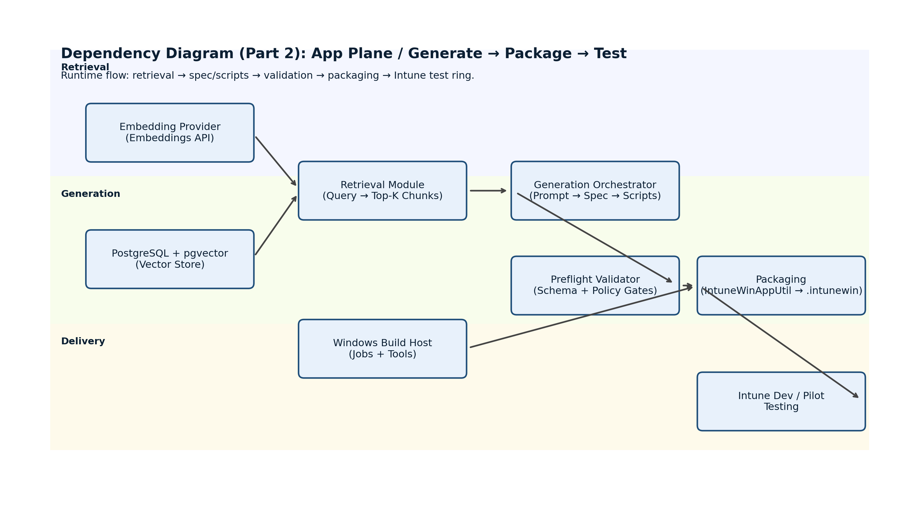

Dependency Diagrams (Labeled)
These labeled diagrams clarify exactly what each dependency represents (credentials, network routes, outputs, and gating conditions).

Part 1: Data Plane / Indexing (Labeled)
Use this to track prerequisites for ingestion and embedding writes into pgvector.
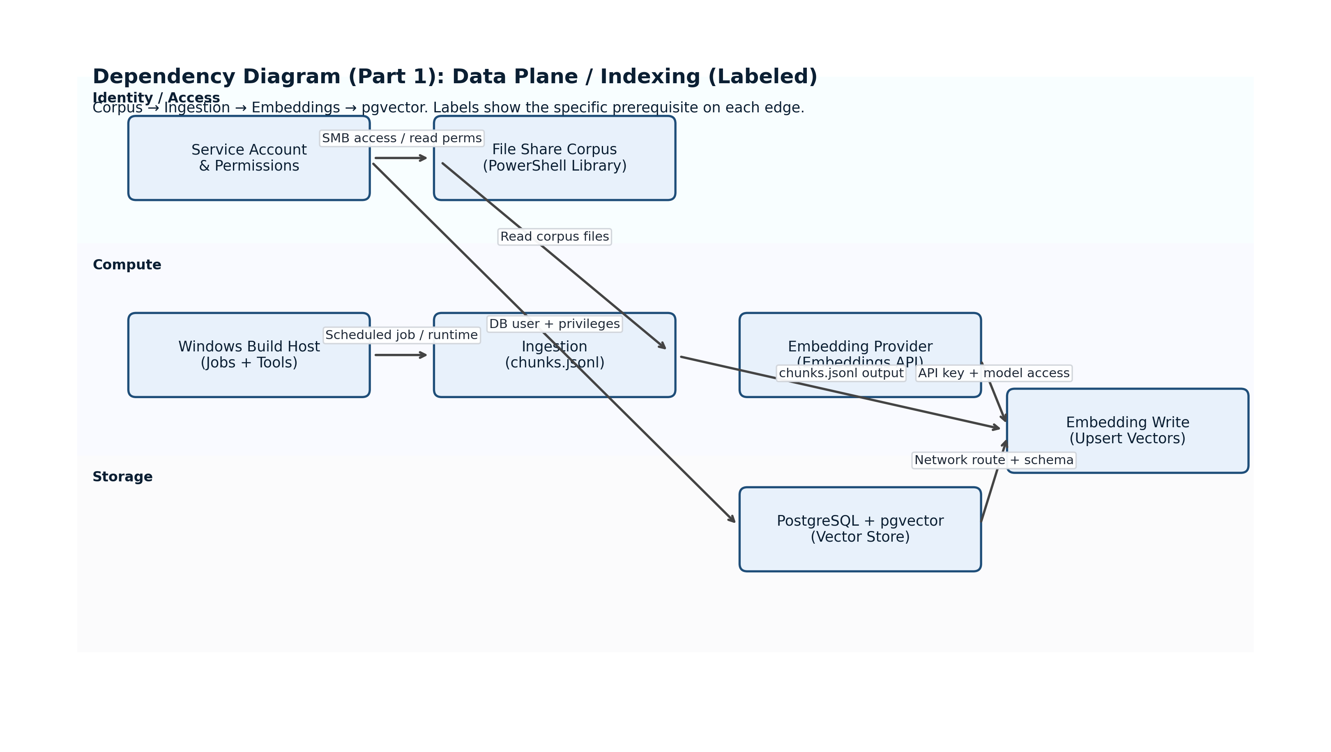

Part 2: App Plane / Generation & Delivery (Labeled)
Use this to track runtime dependencies from retrieval through packaging and testing.
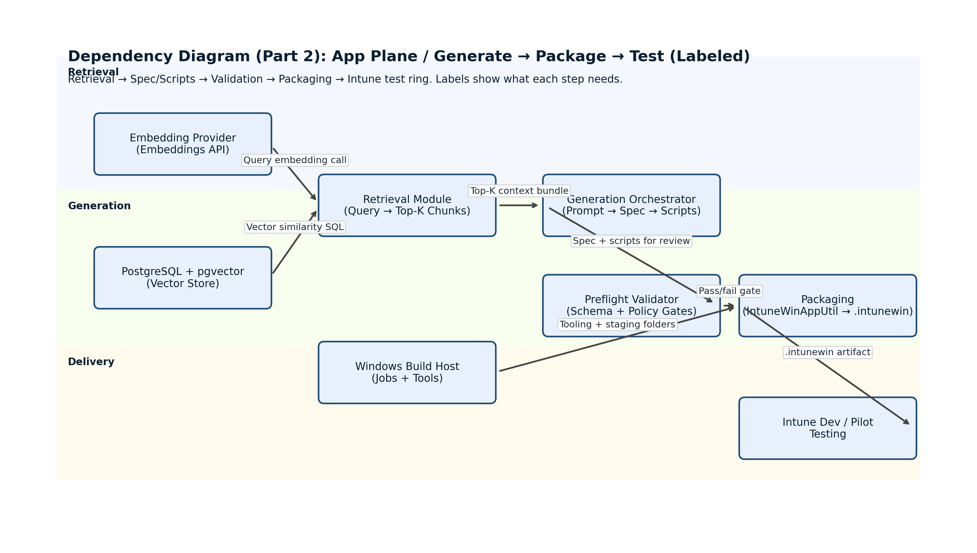

Dependency Diagrams (Action-Verb Labels)
These diagrams replace the earlier label wording with action verbs, so each arrow reads like a task (e.g., "Grant", "Schedule", "Generate", "Run", "Deploy").

Part 1: Data Plane / Indexing (Action Labels)
Use this to track tasks required to build and refresh the RAG index in pgvector.
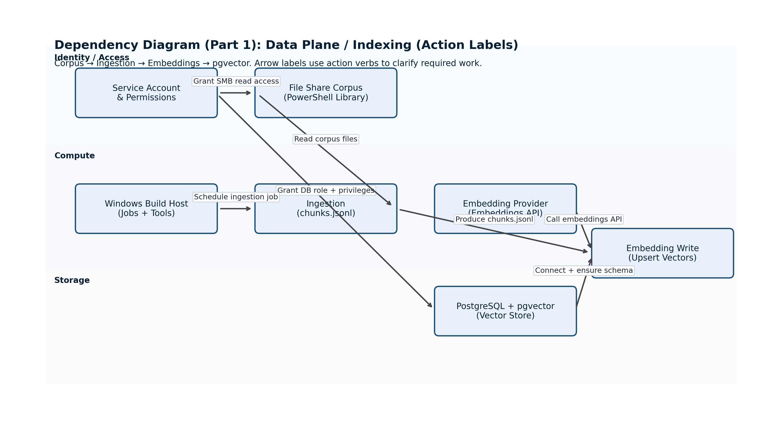

Part 2: App Plane / Generation & Delivery (Action Labels)
Use this to track runtime tasks from retrieval through packaging and Intune testing.
